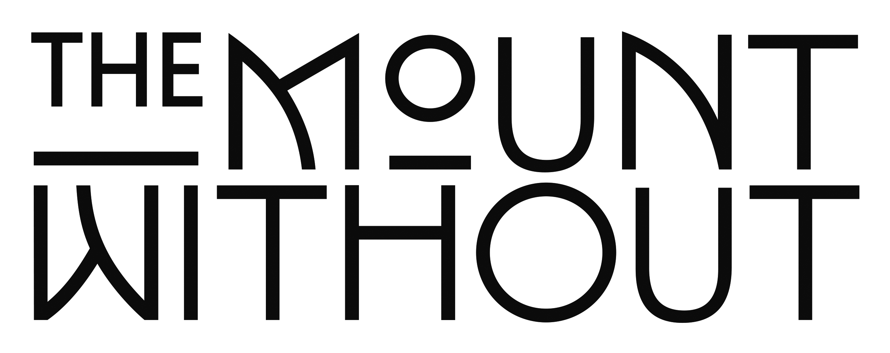
WORKSHOPS 2022

PRICING & OPTIONS

Monday - Thursdays only:

Half day or set up day - £250 – Dry Hire includes
Tables/chairs/sofas/Rugs/cleaning/lighting/clothes rail/kitchen facilities

Full day - £500 – Dry Hire includes
Tables/chairs/sofas/Rugs/cleaning/lighting/clothes rail/kitchen facilities

You are welcome to bring in your own lunch or catering team or we can organize this on your behalf. Do let us know if you require any drinks hot or cold, alcoholic or non.

*Hourly rates are available at short notice and local companies will also get a lower local rate.

Any further queries do please email Michele@themountwothout.co.uk for a bespoke quote

